Hoplonemertea sp. B SCAMIT SCAMIT Vol. , No
Group: Nemertea: Enopla: Hoplonemertea

Date Examined: 16 August 2011
Voucher By: Tony Phillips

SYNONYMY: Hoplonemertea sp HYP1 Phillips 2007
Amphiporidae sp HYP 1 Phillips 2007
Amphiporus sp B Phillips 1988

LITERATURE:
Bernhardt, P. 1979. A key to the Nemertea from the intertidal zone of the coast of California. (Unpublished).
Coe, W.R. 1901. Papers from the Harriman Expedition, 20, the Nemerteans. Proc. Wash. Acad. Sci., 3:1-110.
Coe, W.R. 1905. Nemerteans of the west and north-west coasts of North America. Bull. Mus. Comp. Zool. Harvard Coll. 47:1-319.
Coe, W.R. 1940. Revision of the nemertean fauna of the Pacific Coast of North, Central and northern South America. Allen Hancock Pacific Exped. 2(13):247-323.

DIAGNOSTIC CHARACTERS:
- Body white, thick, generally of uniform width, head narrower with slightly pointed anterior end, posterior end pointed.
- Proboscis sheath extends almost full length of body; proboscis papillated.
- Basis 1.25- 2.5X length of stylet (s/b ratio 0.39 – 0.71) for specimens 5 – 9 mm; basis truncate and tubular, one accessory pouch observed with 1-2 accessory stylets.

- Eyes not visible uncleared; cleared specimens with single row of 4-5 round eyes along each side of anterior-lateral edge of head, single pair of large crescent eyes on each side of brain lobes, just posterior to cephalic groove.

RELATED SPECIES AND CHARACTER DIFFERENCES:
The distinct, cleared eye pattern observed has not been seen in any other enoplan found in the southern California Bight.

DEPTH RANGE: 5-30 meters

DISTRIBUTION: San Diego to Goleta

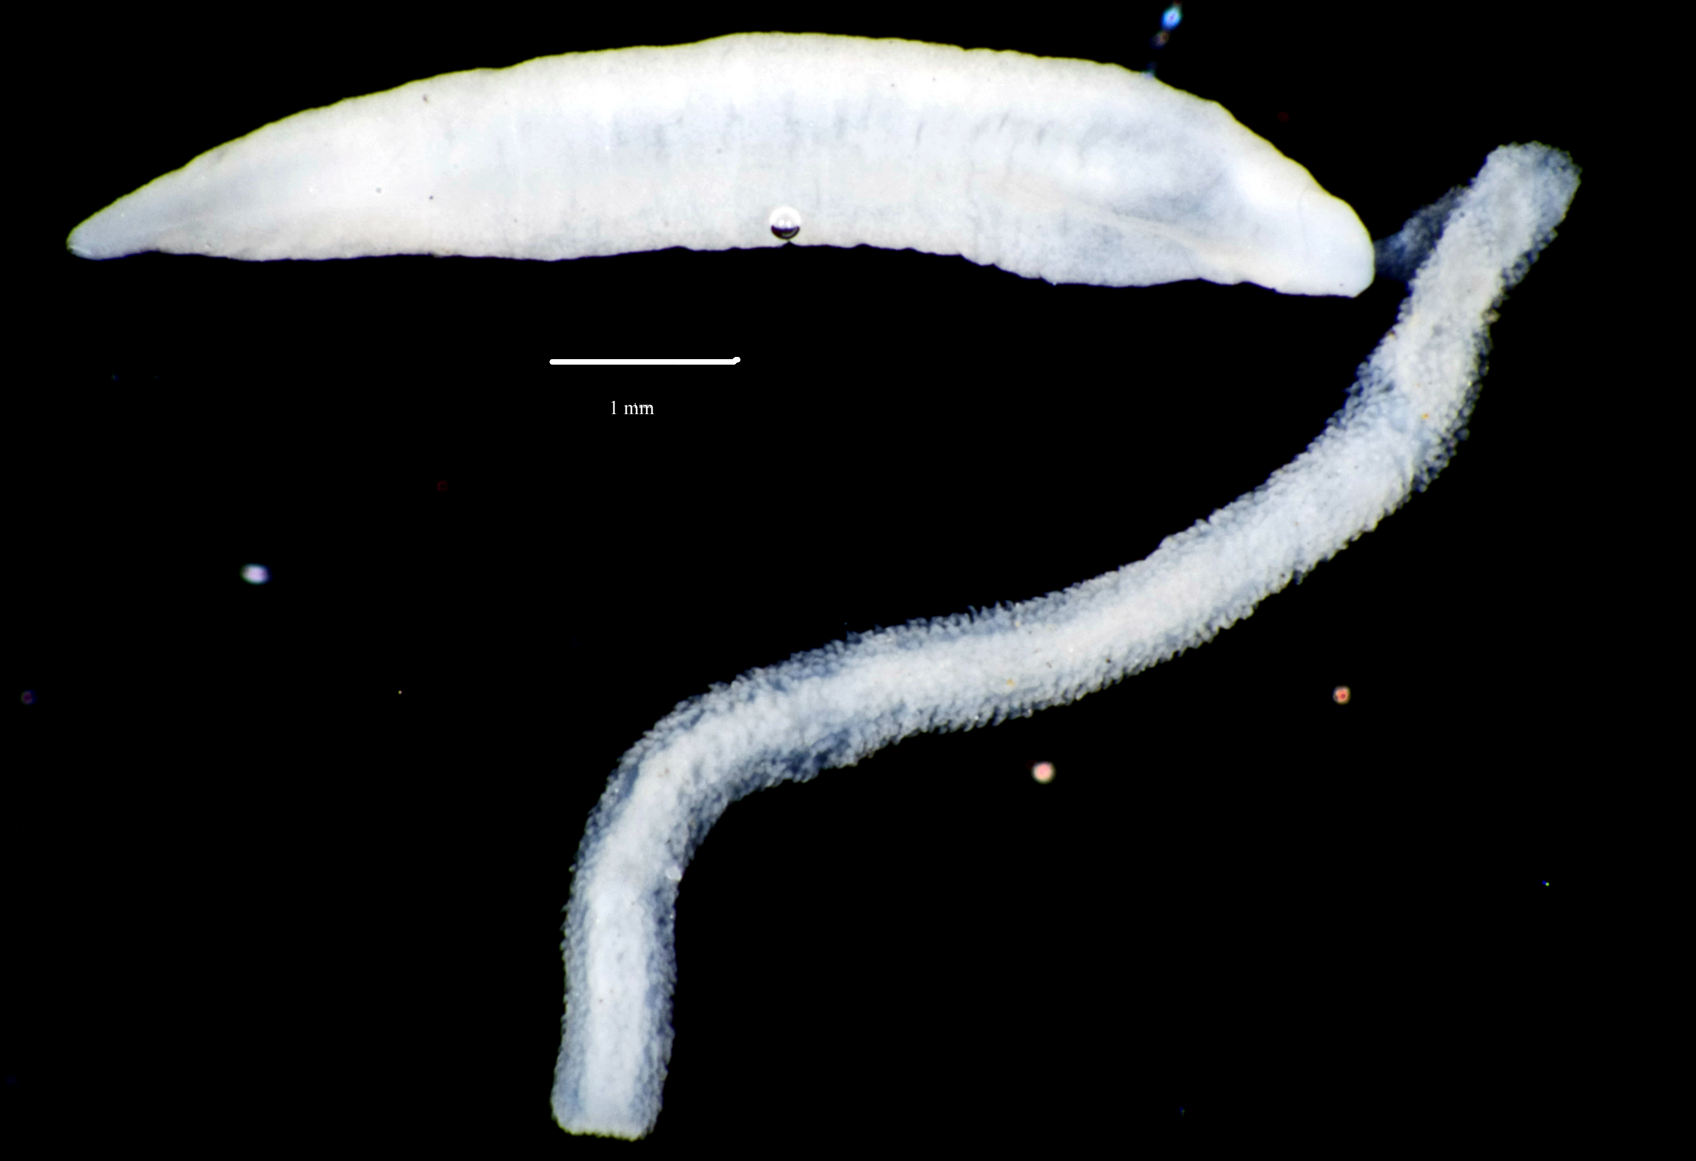

Figure 1. Hoplonemertea sp B SCAMIT. Santa Monica Bay, A2, 16 m, 28 September 2006.

